Suppliers – Stocky Screenshots

Main Screen
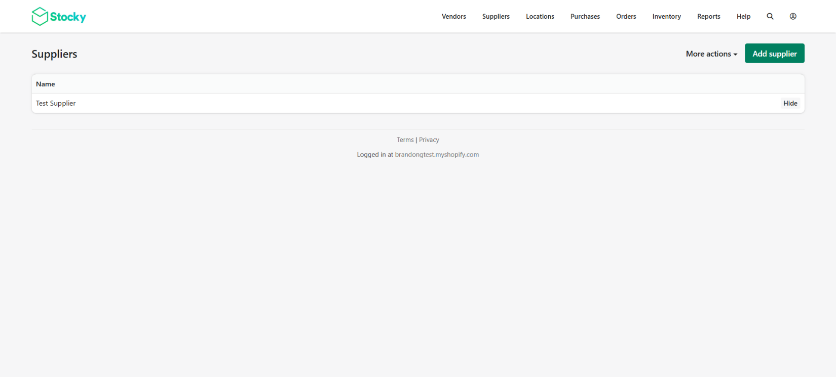

Add Supplier
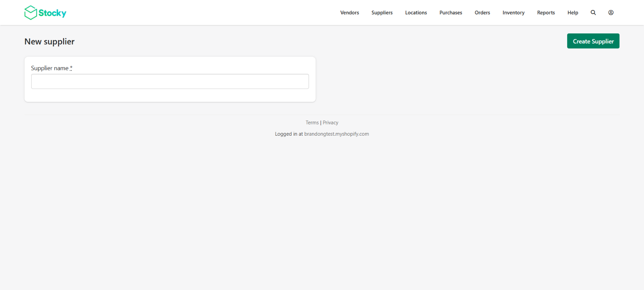
Manage Products
By Shopify Vendor
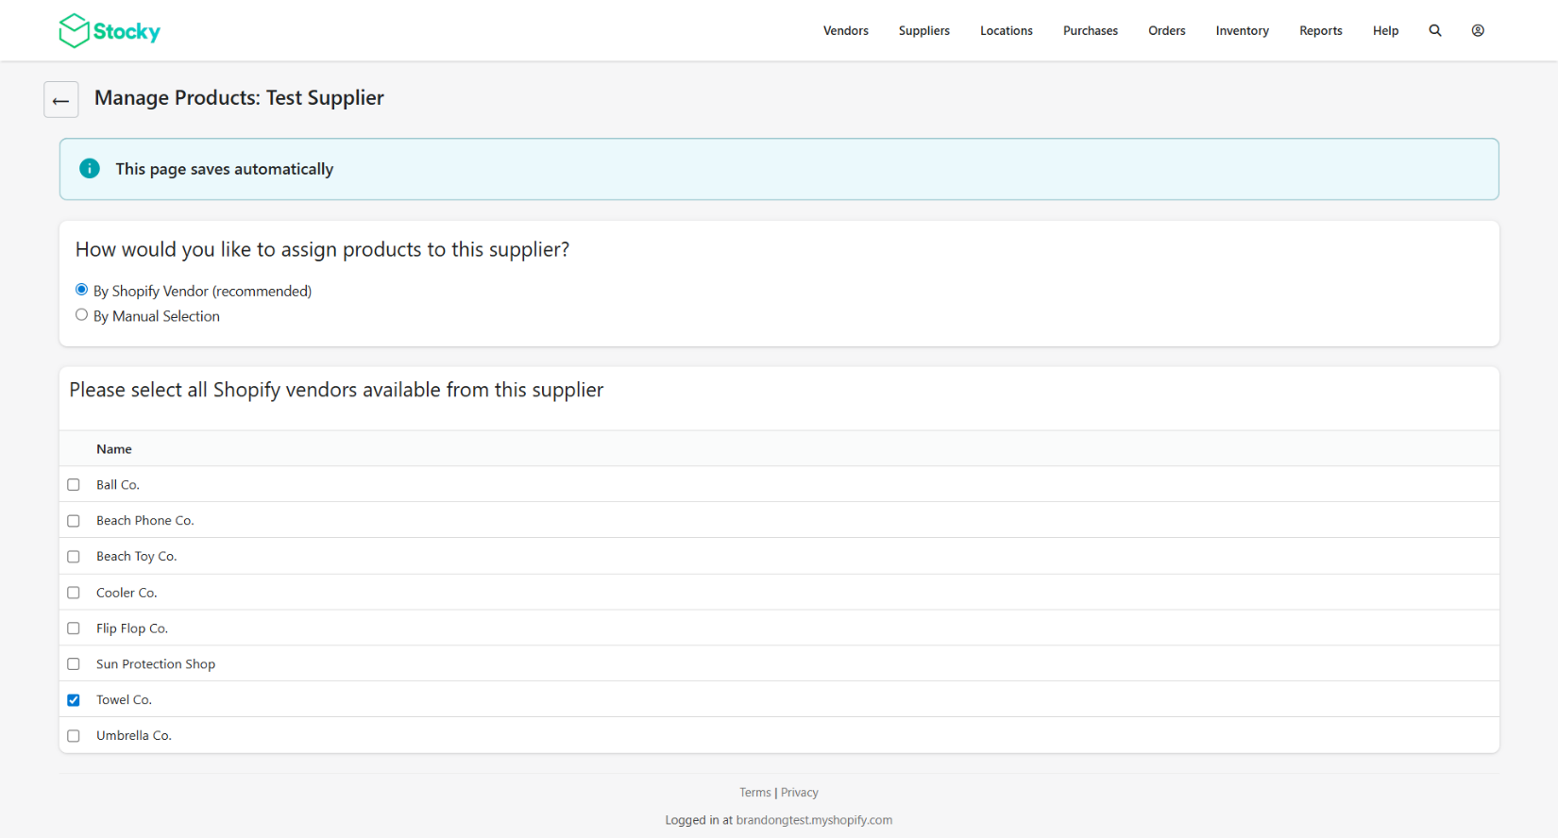
By Manual Selection
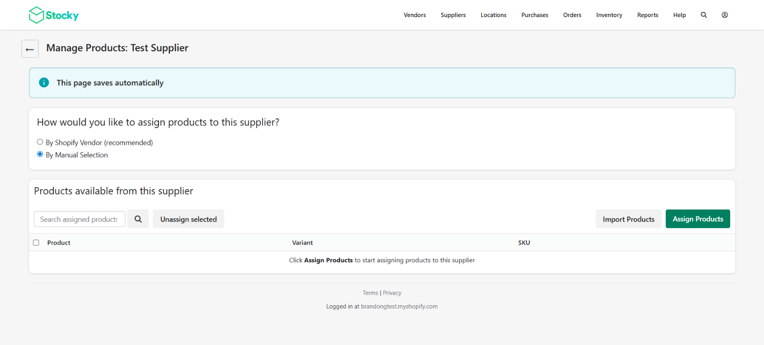
Assign Products
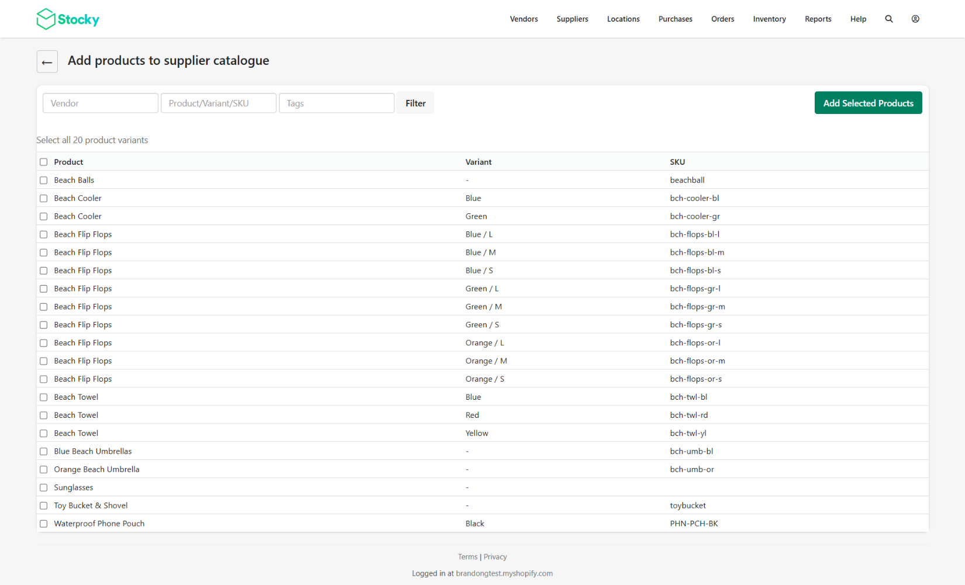
Import Products
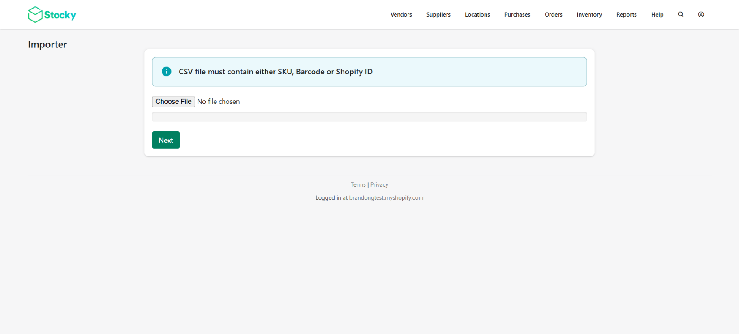
Supplier w/o Products
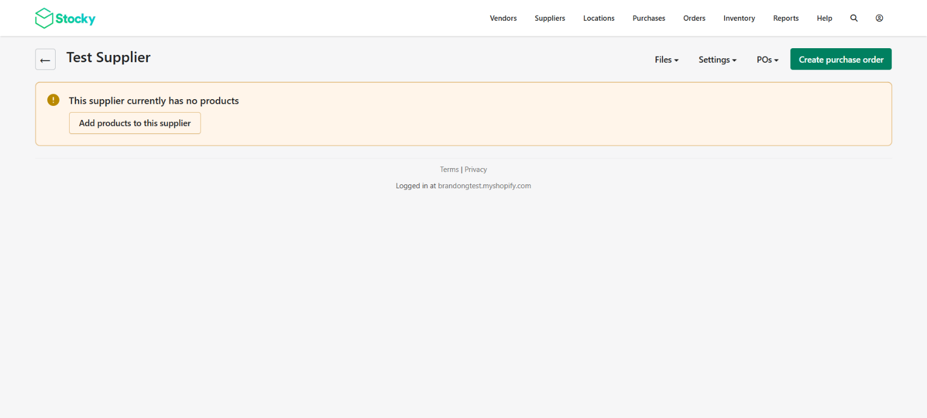
Supplier with Assigned Products
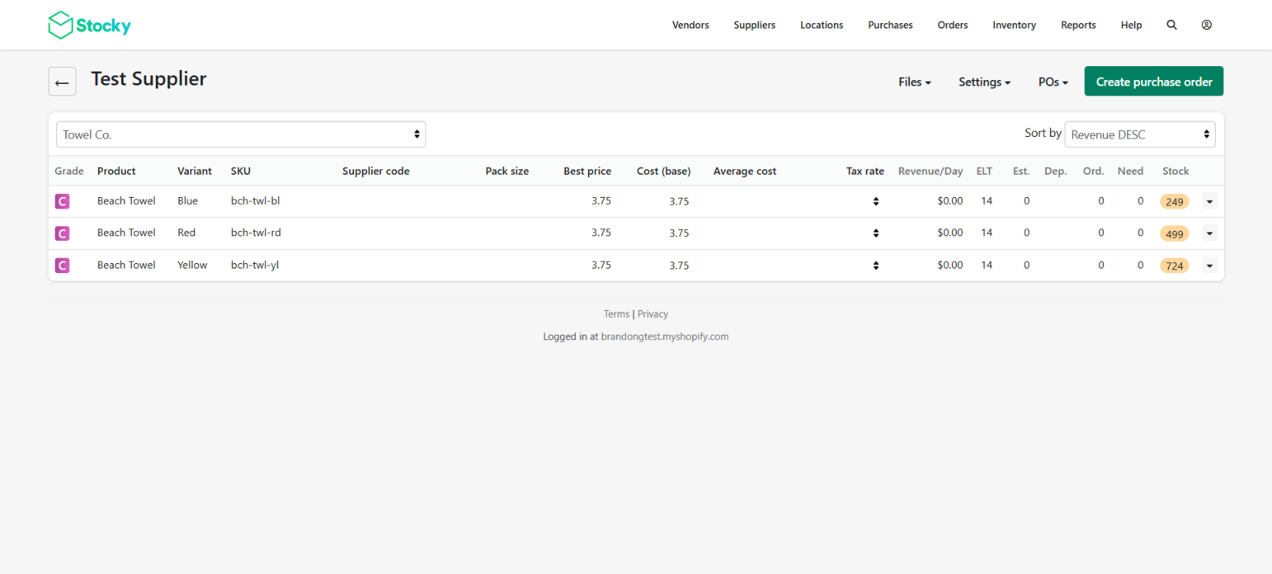
Manage Products – Click Product Column
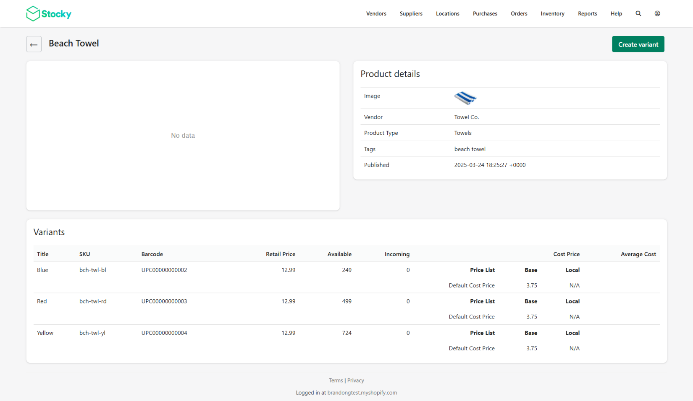

Manage Products – Click Variant Column
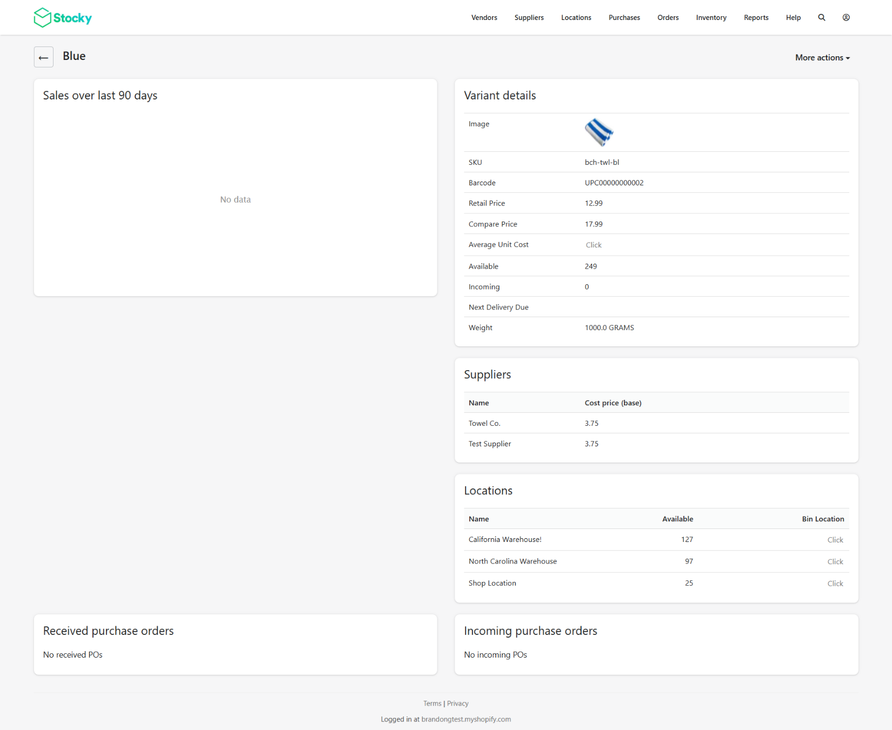
Order Limits
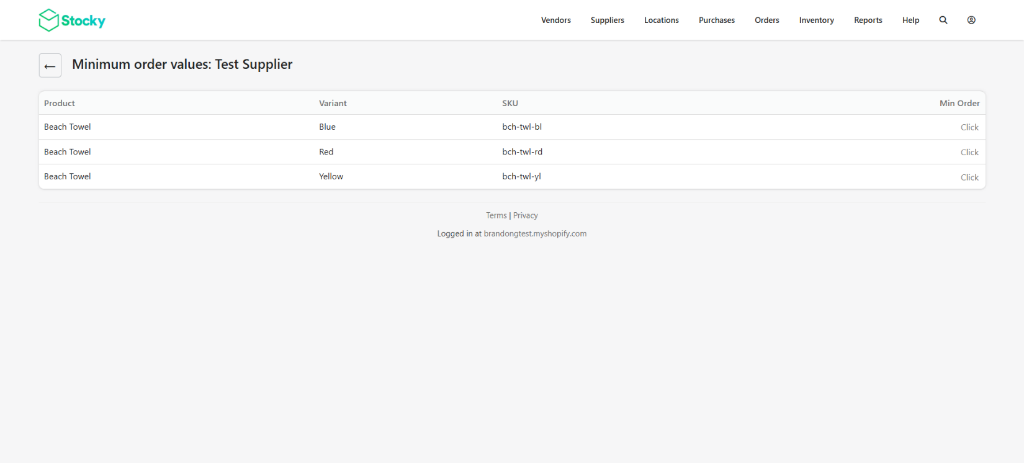
Lead Times
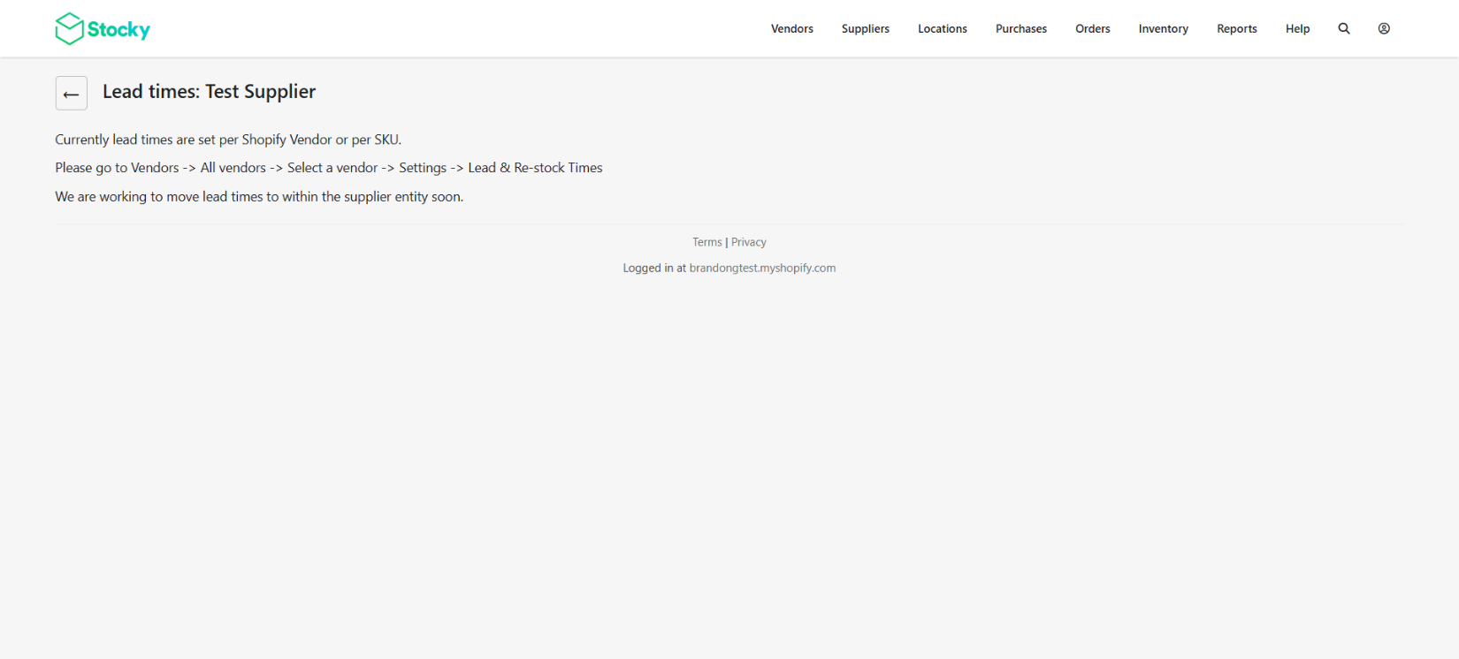
Import
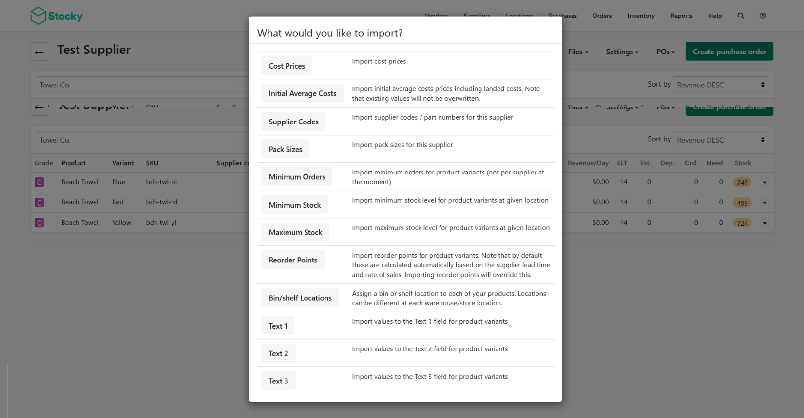
Details
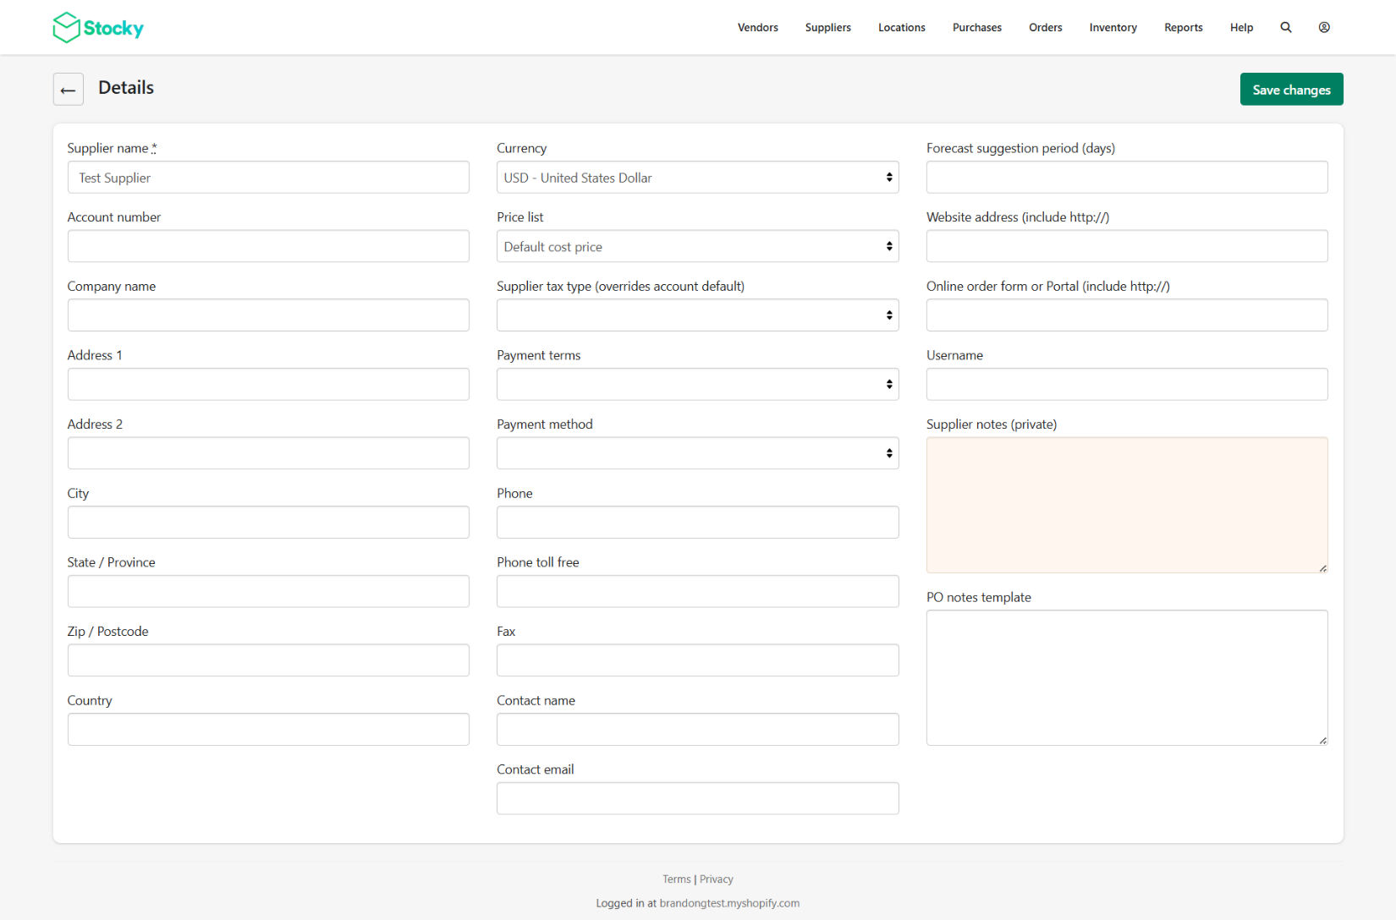

My Version
Create New Supplier
- Click “Create Supplier”
- Enter Criteria
- Click “Save”

Field Name | Description | Required | Constraints
Supplier Name | A friendly internal name of the supplier that is displayed in Stock Buddy screens | Yes
Supplier Number | A unique value representing the supplier | Yes
AP Number | A unique value representing the supplier in the accounting system | No
Company Name | The formal legal company name that prints on PO forms, etc. | Yes
Address 1 | Purely informational for printing and/or display purposes only | Yes
Address 2 | Purely informational for printing and/or display purposes only | No
City | Purely informational for printing and/or display purposes only | Yes
State/Province | Purely informational for printing and/or display purposes only | Yes
Zip Code / Postal Code | Purely informational for printing and/or display purposes only | Yes
Country | Purely informational for printing and/or display purposes only | Yes
Currency | Purely informational for printing and/or display purposes only | Yes
Price List | Controls the cost that appears on a PO and is used internally for forecasting.
Supplier Tax Type | Simply puts a note somewhere on the PO that says either "tax included" or "tax not included".  - If the supplier’s prices are marked tax included, Stocky assumes the unit cost already includes tax and does not add tax on top.  If marked tax excluded, Stocky adds the supplier’s tax rate (if provided) to the PO total.
Payment Terms | Purely informational for printing and/or display purposes only
Payment Method | Purely informational for printing and/or display purposes only
Phone | Purely informational for printing and/or display purposes only
Phone Toll Free | Purely informational for printing and/or display purposes only
Fax | Purely informational for printing and/or display purposes only
Contact Name | Purely informational for printing and/or display purposes only
Contact Email | Purely informational for printing and/or display purposes only
Forecast Suggestion Period (days) | Controls the # of days of history used by Stocky’s forecasting engine.
Website | Purely informational for printing and/or display purposes only
Online Order Form or Portal | Purely informational for printing and/or display purposes only
Username | Purely informational for printing and/or display purposes only
Supplier Notes (private) | Purely informational for internal use only
PO Notes Template | A block of text that’s included on every PO for the supplier. It can be anything.
PO Email
Lead Days

Forecasting Model
Stocky’s forecasting is built on a simple demand‑based replenishment model:
1. Look at past sales for a product
Stocky pulls historical sales from Shopify for a given period (e.g., last 30 days).
2. Calculate average daily sales
Example:
If you sold 60 units in 30 days → average = 2 units/day.
3. Multiply by the supplier’s lead time
If the supplier takes 14 days to deliver:
2 units/day × 14 days = 28 units needed to avoid running out.
4. Adjust for safety stock (optional)
Merchants can set a buffer (e.g., 20%).
28 units × 1.2 = 33.6 → 34 units.
5. Subtract what you already have
If you have 10 units on hand and 5 incoming:
34 – (10 + 5) = 19 units to order.
6. Suggest that quantity on the PO
Stocky fills in “19” as the suggested reorder quantity.

